FREEDOM DAY 2012, Toronto
September 20, 2012
“A day to carry on Simon Wiesenthal’s legacy of tolerance, justice & human rights
A day to celebrate freedom
A day to bring about positive change in our community & in our world”

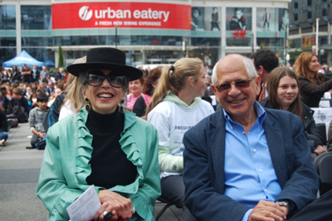
MIGS’ Director Frank Chalk read out a poem of his own creation to nearly 4,000 elementary and high school students who had gathered in downtown Toronto for Freedom Day 2012. The annual event hosted by the Friends of Simon Wiesenthal Center celebrates the legacy of Simon Wiesenthal, an Austrian holocaust survivor who later tracked down Nazis so they could be tried for war crimes.

Prof. Chalk with Dorothy Shoichet, a long-time supporter of the FSWC.

After Holocaust survivor Max Eisen commemorated Simon Wiesenthal, Professor Chalk and award-winning humanitarian, Founder of War Child Canada, Dr. Samantha Nutt celebrated Canada’s values as they sought to educate younger generations about our fundamental human rights. In line with the FSWC’ core values, the speakers’ hope is to raise awareness and empower young people to create change and assume responsibility for the future.

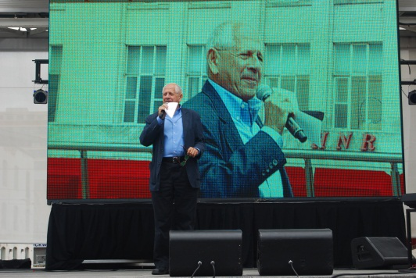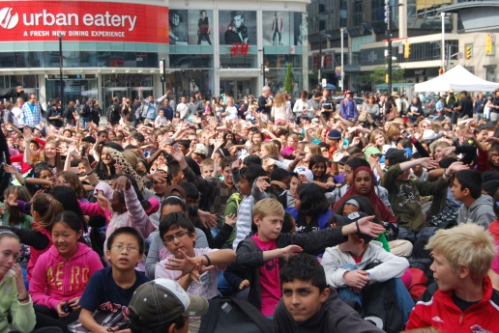
Prof. Chalk reading out a poem to thousands of students and teachers
“Freedom is not a gift from heaven; one must fight for it every day” Simon Wiesenthal
The Wiesenthal Center for Holocaust Studies is dedicated to fostering tolerance and understanding though educational outreach and social action.

